**9. DEVELOPING USER INTERFACE DESIGN**

**AIM:**

To Developing user Interface design using Mobile Application.

**ALGORITHM:**

**Step 1**: Create a new layout file named activity_main.xml in the res/layout directory.

**Step 2**: Define a LinearLayout as the root layout with vertical orientation, allowing for

 stacked elements. Set its width and height to match the parent.

**Step 3**: Add a TextView to display the title of the interface. Set its properties such as text size,

 style, and gravity for proper alignment.

**Step 4**: Include an EditText field for user input. Set a hint to guide users on what to enter and

 ensure it is wide enough to fill the available space.

**Step 5**: Add a Button below the EditText that users can click to submit their input. Center it

 and give it some margin for spacing.

**Step 6**: Insert another TextView that will be used to display output based on the user’s input

 after they press the button. Set its text size for visibility.

**Step 7**: In MainActivity.java, initialize the UI components in the onCreate() method, set the

 OnClickListener for the button, and define the action that will occur when the button

 is clicked (updating the output TextView with the user’s input).

**Step 8**: Stop the Process.

**CODING:**

**activity_main.xml :**

<?xml version="1.0" encoding="utf-8"?>

<LinearLayout xmlns:android="http://schemas.android.com/apk/res/android"

    android:layout_width="match_parent"

    android:layout_height="match_parent"

    android:orientation="vertical"

    android:padding="16dp">

    <TextView

        android:id="@+id/titleTextView"

        android:layout_width="wrap_content"

        android:layout_height="wrap_content"

        android:text="User Interface Design Example"

        android:textSize="24sp"

        android:textStyle="bold"

        android:layout_gravity="center" />

    <EditText

        android:id="@+id/inputEditText"

        android:layout_width="match_parent"

        android:layout_height="wrap_content"

        android:hint="Enter something"

        android:layout_marginTop="20dp" />

    <Button

        android:id="@+id/actionButton"

        android:layout_width="wrap_content"

        android:layout_height="wrap_content"

        android:text="Submit"

        android:layout_gravity="center"

        android:layout_marginTop="20dp"/>

    <TextView

        android:id="@+id/outputTextView"

        android:layout_width="wrap_content"

        android:layout_height="wrap_content"

        android:layout_marginTop="20dp"

        android:textSize="18sp"/>

</LinearLayout>

**AndroidManifest.xml :**

<manifest xmlns:android="http://schemas.android.com/apk/res/android"

    package="com.example.uidesigndemo">

    <application

        android:allowBackup="true"

        android:icon="@mipmap/ic_launcher"

        android:label="@string/app_name"

        android:roundIcon="@mipmap/ic_launcher_round"

        android:supportsRtl="true"

        android:theme="@style/Theme.AppCompat.Light.DarkActionBar">

        <activity

            android:name=".MainActivity"

            android:exported="true"> <!-- Specify exported attribute -->

            <intent-filter>

                <action android:name="android.intent.action.MAIN" />

                <category android:name="android.intent.category.LAUNCHER" />

            </intent-filter>

        </activity>

    </application>

</manifest>

**MainActivity.java :**

package com.example.uidesigndemo;

import android.os.Bundle;

import android.view.View;

import android.widget.Button;

import android.widget.EditText;

import android.widget.TextView;

import androidx.appcompat.app.AppCompatActivity;

public class MainActivity extends AppCompatActivity {

    private EditText inputEditText;

    private Button actionButton;

    private TextView outputTextView;

    @Override

    protected void onCreate(Bundle savedInstanceState) {

        super.onCreate(savedInstanceState);

        setContentView(R.layout.activity_main);

        inputEditText = findViewById(R.id.inputEditText);

        actionButton = findViewById(R.id.actionButton);

        outputTextView = findViewById(R.id.outputTextView);

        actionButton.setOnClickListener(new View.OnClickListener() {

            @Override

            public void onClick(View v) {

                String input = inputEditText.getText().toString();

                outputTextView.setText("You entered: " + input);

            }

        });

    }

}

**OUTPUT :**

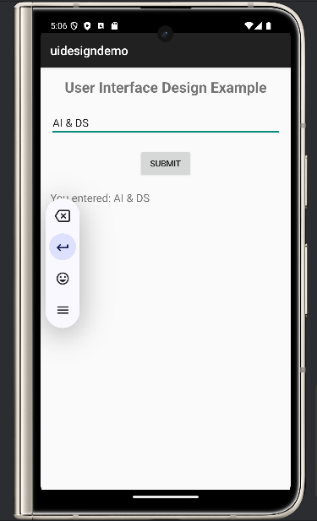

**RESULT:**

The above program has been successfully executed.